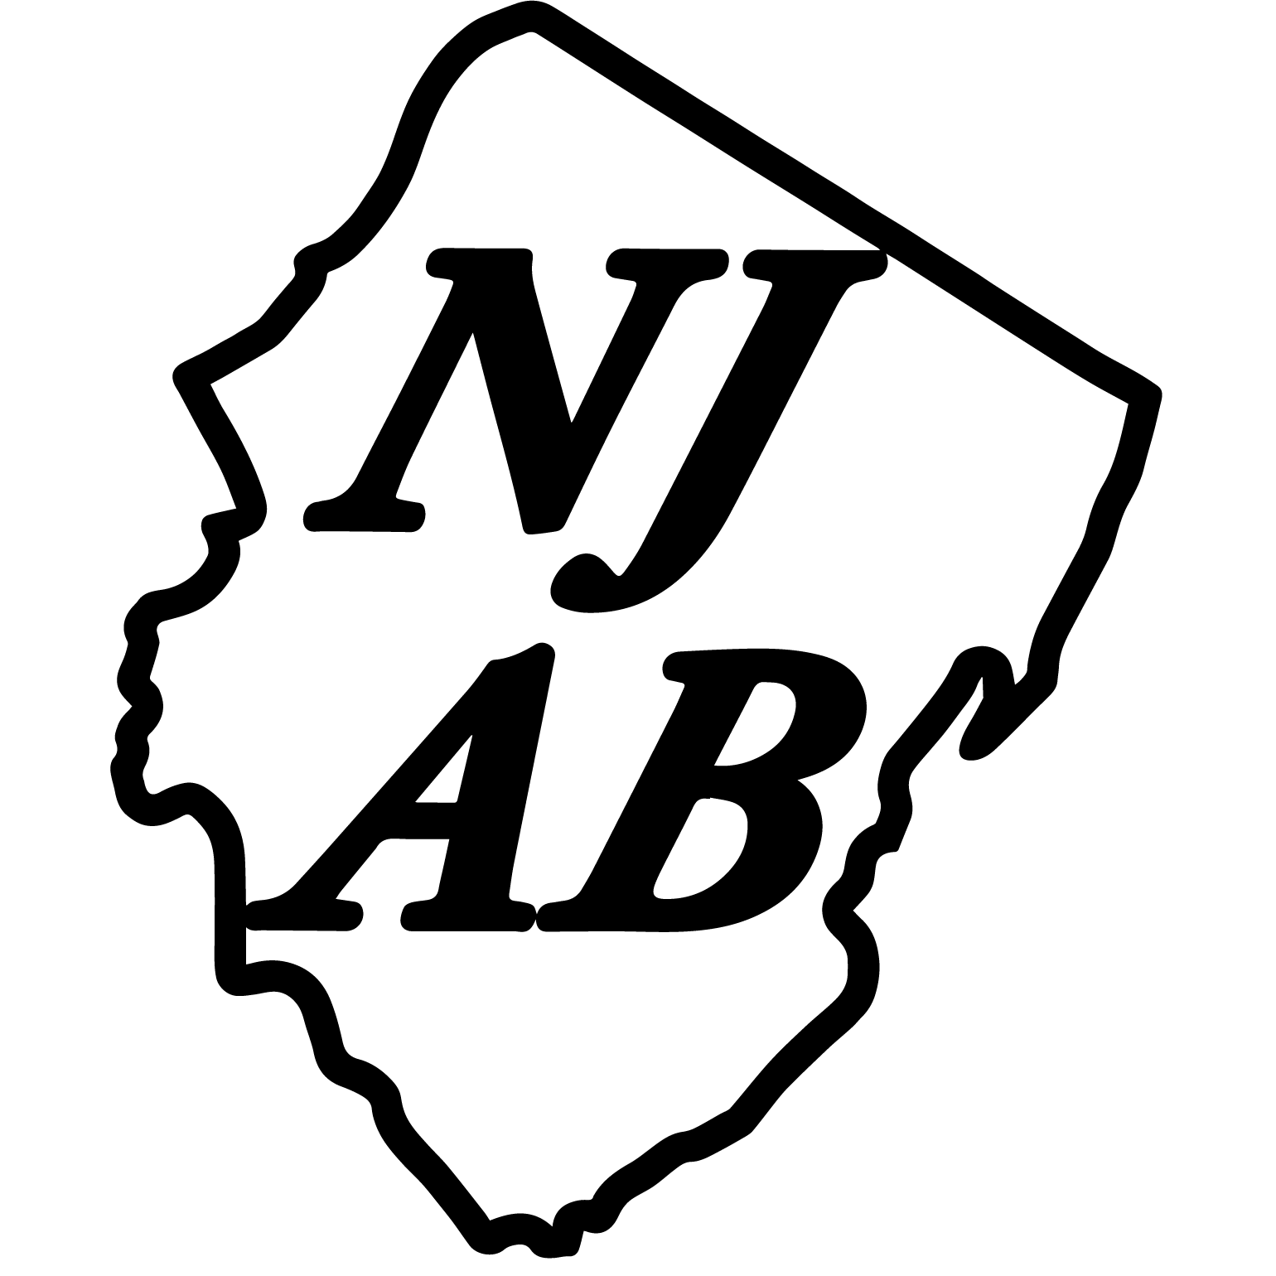
2nd Annual North Jersey Area Band Concert Band Festival
April 12, 2018
Dover High School

School:_______________________________________________
Address:_____________________________________________
School Phone:________________________________________
Email:_______________________________________________
Director:_____________________________________________
Personal Phone:______________________________________
Name of Group:_______________________________________
Number of Musicians:_________________________________

Director’s Signature:__________________________________

Please send application and registration check for $100 (made payable to NJAB) to:
Daniel Vazquez
Dover High School
100 Grace Street
Dover, NJ 07801

